

Empathy Map

Date | 30 September 2026
Team ID | SWTID-2026-3326
Project Name | Blog Nest
Maximum Marks | 4 Marks

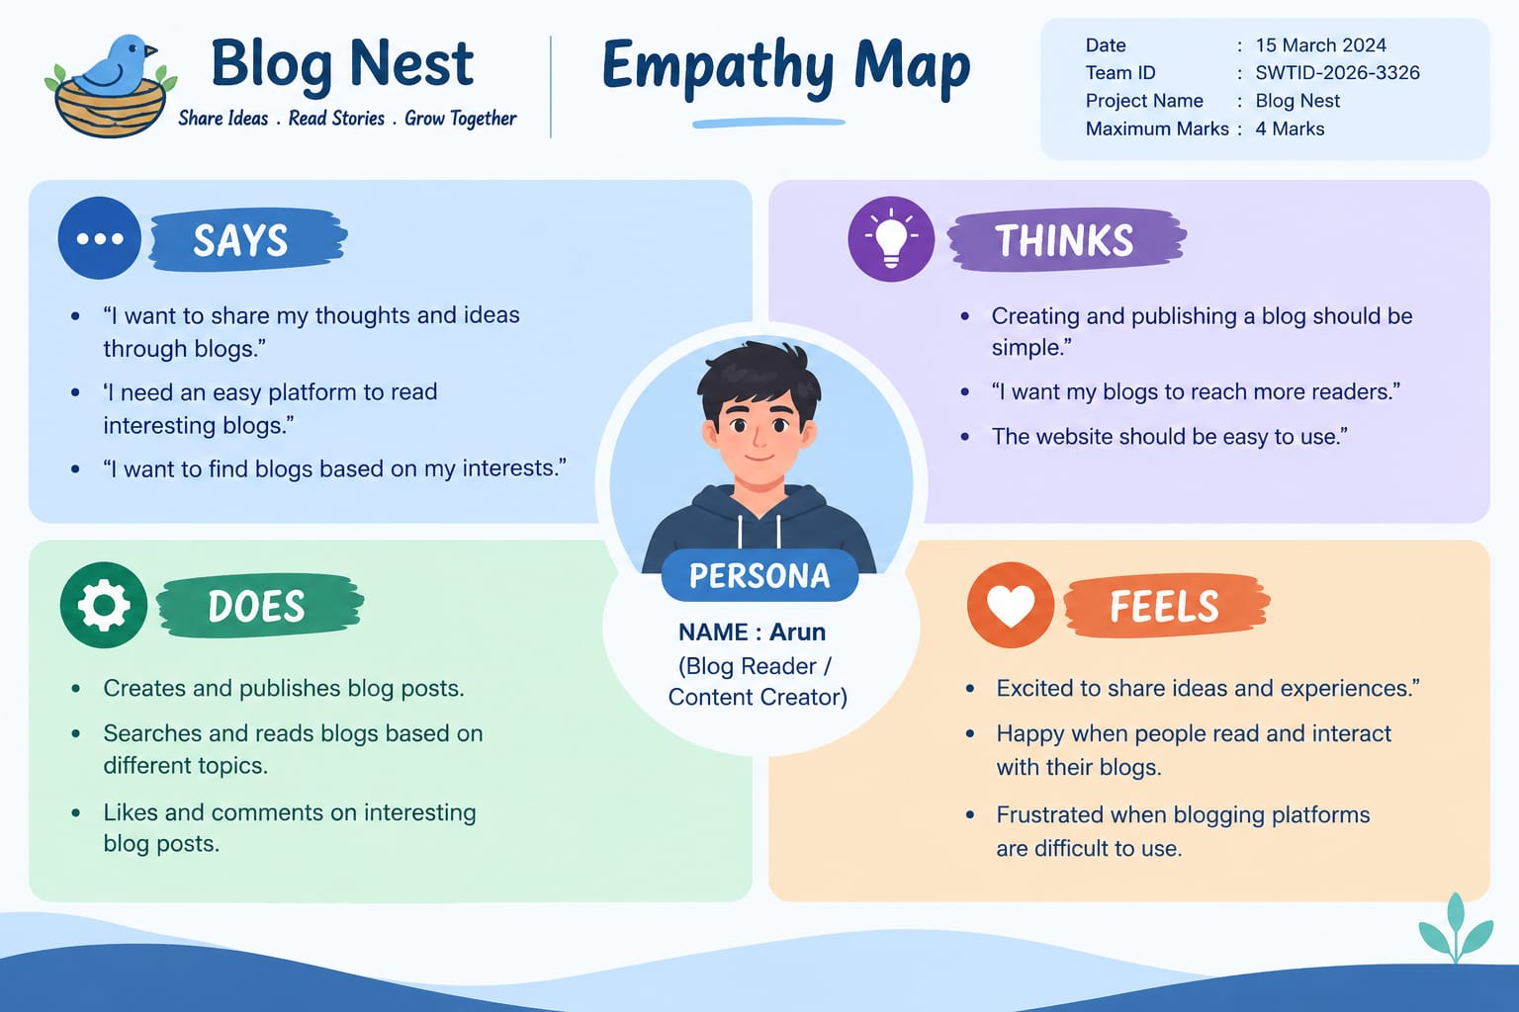
Empathy Map

